**GERBANG LOGIKA**

**Dosen Pengampun : Laksamana Rajendra Haidar A.F.,S.Kom**

**Carilah komponen seperti dibawah menggunakan multisim 13**

|  |  |  |  |
| --- | --- | --- | --- |
| **No** | **Nama** | **Keterangan** | **Jumlah** |
| **1** | **DSWPK_6** | **Place Basic** | **1** |
| **2** | **OR2** | **Place Misc Digital** | **2** |
| **3** | **AND2** | **Place Misc Digital** | **3** |
| **4** | **NOT** | **Place Misc Digital** | **1** |
| **5** | **LED red** | **Place Diodes** | **1** |
| **6** | **Ground** | **Place Source** | **1** |
| **7** | **VCC** | **Place SOurce** | **1** |

Rangkailah Seperti Dibawah ini

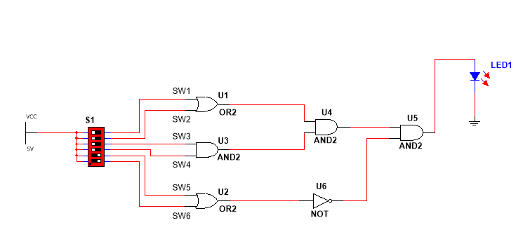

3.Kemudian Jalankan dengan menekan F5 atau run

|  |  |  |  |  |  |  |
| --- | --- | --- | --- | --- | --- | --- |
| Saklar1 | Saklar2 | Saklar3 | Saklar4 | Saklar5 | Saklar6 | Kondisi lampu |
| 0 | 0 | 0 | 0 | 0 | 0 | MATI |
| 1 | 0 | 1 | 0 | 0 | 1 | MATI |
| 0 | 0 | 0 | 1 | 1 | 0 | MATI |
| 0 | 1 | 0 | 1 | 0 | 1 | MATI |

4.Simpan Project dengan nama Gerbang Logika.ms13